Project Design Phase
Solution Architecture
Date | 14 July 2026
Team ID | [Your Team ID]
Project Name | SB Stocks – Virtual Stock Trading Platform
Maximum Marks | 4 Marks

Solution Architecture Diagram
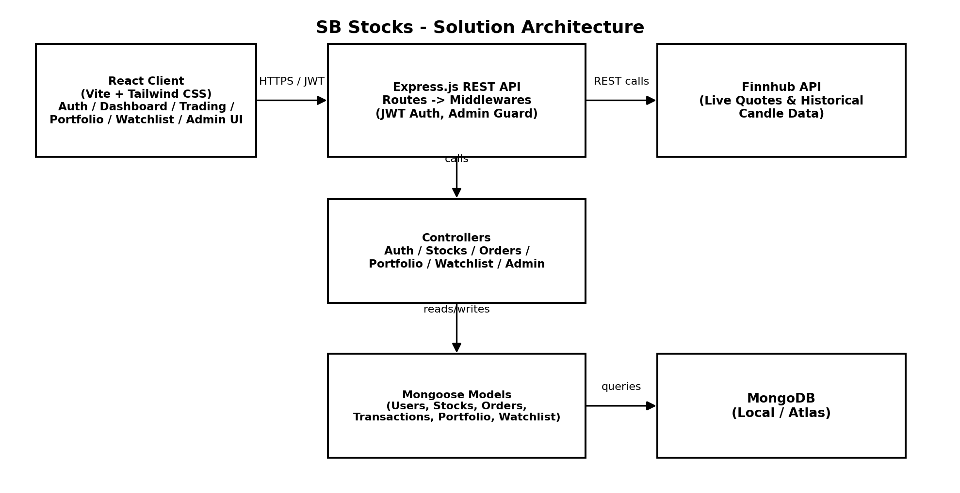

Architecture Description
SB Stocks uses a 3-tier MERN architecture with one external dependency (Finnhub):
- Presentation tier – a React (Vite) single-page application styled with Tailwind CSS. It handles authentication forms, the trading dashboard, portfolio, watchlist, and the admin panel, and talks to the backend only over authenticated REST calls (Axios).
- Application tier – an Express.js server exposes REST routes grouped by domain (auth, stocks, orders, portfolio, transactions, watchlist, admin). JWT middleware protects user routes; an additional admin-guard middleware protects admin-only routes. Controllers hold the business logic — e.g. validating wallet balance before executing a buy order.
- Data tier – Mongoose models define schemas for Users, Stocks, Orders, Transactions, Portfolio holdings and Watchlist entries, persisted in MongoDB (local MongoDB Compass in development, MongoDB Atlas in production).
- External integration – the Stocks controller calls the Finnhub API to fetch live quotes and historical price data, which is transformed into the candlestick chart data shown on the client.
Key Design Decisions
- Stateless authentication (JWT) avoids server-side session storage, simplifying horizontal scaling of the API tier.
- Order execution and wallet/portfolio updates are handled inside a single controller flow to keep balance and holdings consistent.
- Live-market calls are isolated to the Stocks controller so the Finnhub integration can be swapped or extended (e.g. additional exchanges) without touching trading logic.

